|  |  |  |
| --- | --- | --- |
|  | **BAHRIA UNIVERSITY, (Karachi Campus)**  *Department of Software Engineering*  **Assignment 1 - Spring 2025** |  |



COURSE TITLE: DevOps COURSE CODE: SEN-429

Class: **BSE-8 A & B** Shift: **Morning**

Course Instructor: Sohaib Ur RehmanTime Allowed:  **2 Week**

Submission Date: **6th April 2025** Max. Marks: **5 Marks**

**Name: Muhammad Shoaib Akhter Qadri Enrollment No: 02-131212-009**

**Assignment: VPC Peering Between N. Virginia and Ohio Regions** **[CLO3: 5 Marks] Objective**

Set up VPC Peering between two AWS regions:

1. **VPC 1** in **N. Virginia (us-east-1)**
2. **VPC 2** in **Ohio (us-east-2)**

Deploy the following instances:

* A **Windows EC2 instance** in the **public subnet** of the **N. Virginia VPC**
* A **Linux EC2 instance** in the **private subnet** of the **Ohio VPC**

Enable communication between the two instances over a private network via VPC Peering.

## ****Success Criteria:****

✅ **VPC Peering is established** between N. Virginia and Ohio  
✅ **Routing tables are correctly updated** for inter-VPC communication  
✅ **Windows EC2 (N. Virginia) is accessible via RDP** over public IP  
✅ **Linux EC2 (Ohio) is reachable from Windows EC2** using private IP  
✅ **Ping test between instances is successful**  
✅ **SSH connection from Windows to Linux over private IP works**

**Note:** Ensure to include detailed snapshots and step-by-step explanations for each stage of the setup to enhance clarity and understanding.

**Solution:**

**1.1 Create the VPC (Non-Overlapping CIDR)**

* **Region: N. Virginia (us-east-1)**
* **VPC Name: Virginia-VPC-Shoaib**
* **IPv4 CIDR: 10.0.0.0/16**

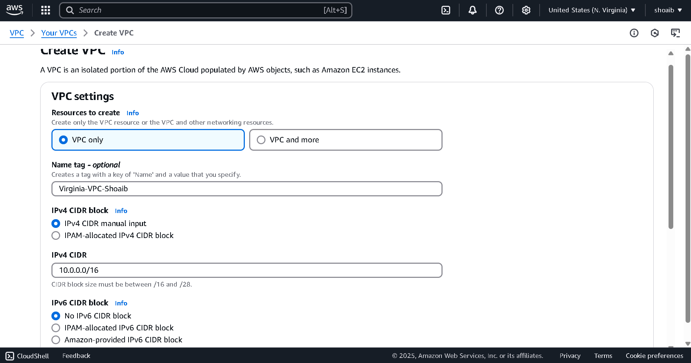

**1.2 Create Subnets**

**Public Subnet (for Windows EC2)**

* **Name:** Virginia-Public-Subnet-Shoaib
* **VPC:** Virginia-VPC-Shoaib
* **Availability Zone:** us-east-1a
* **CIDR:** 10.0.1.0/16

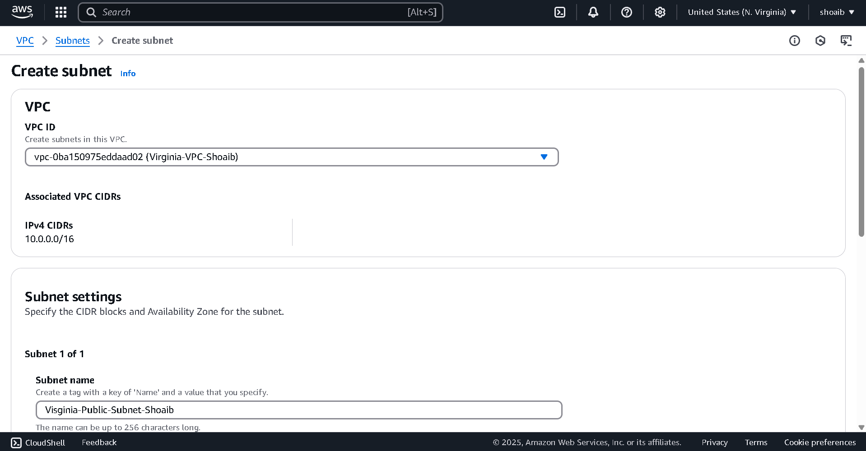

**1.3 Create Internet Gateway (IGW)**

* **Name:** Virginia-IGW-Shoaib

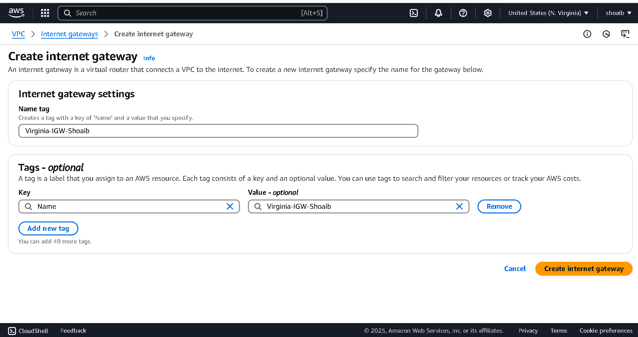

Now attached IGW with VPC  
  
Create Route Table  
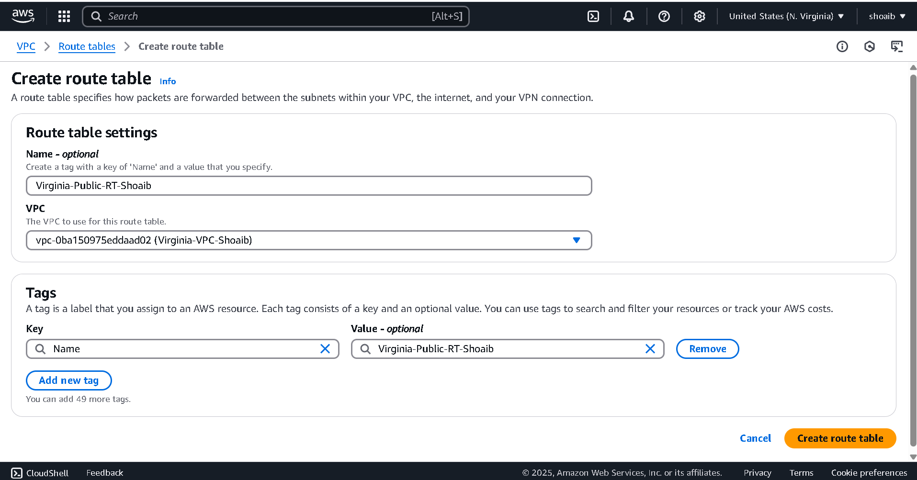

Now click Edit Route and assigned new IP and select Internet Gateway and select your IGW.

Now do subnet associations

Now create second vpc under ohio region

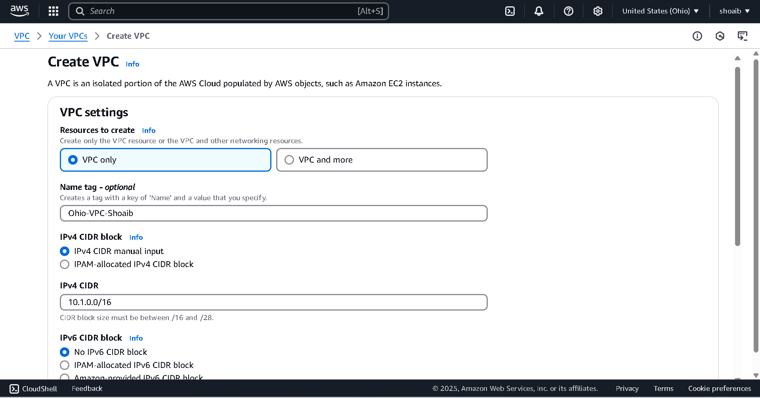

Create Subnet

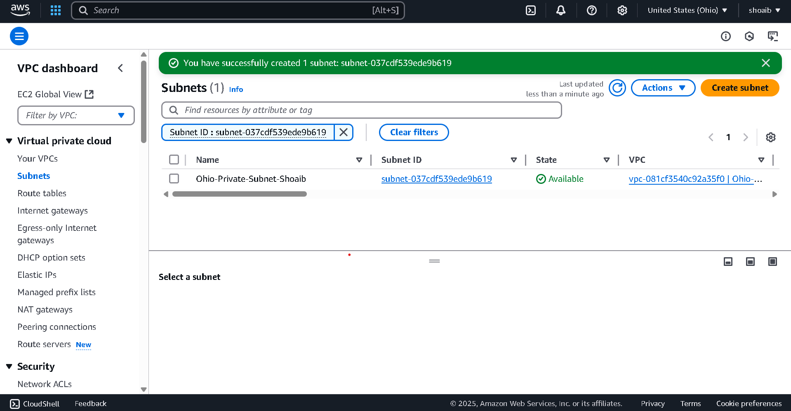

Create Route Table  
  
Edit Subnet Association  
  
Create Peering Connection under Virginia region  
  
Accept Request under Ohio Region

Edit Route under Virginia  
  
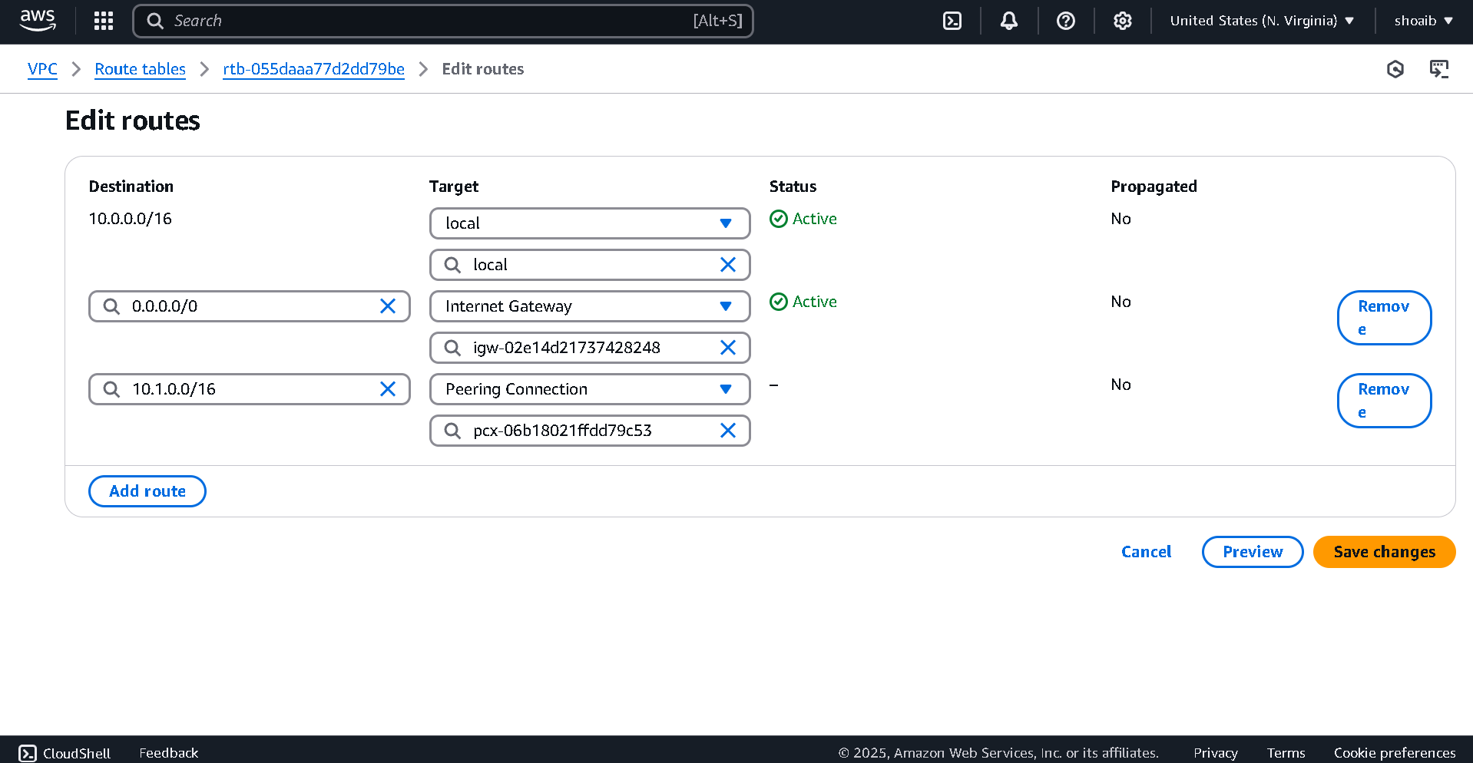

Edit Route under Ohio Region

Add Instance in EC2 under Virginia Region  
  
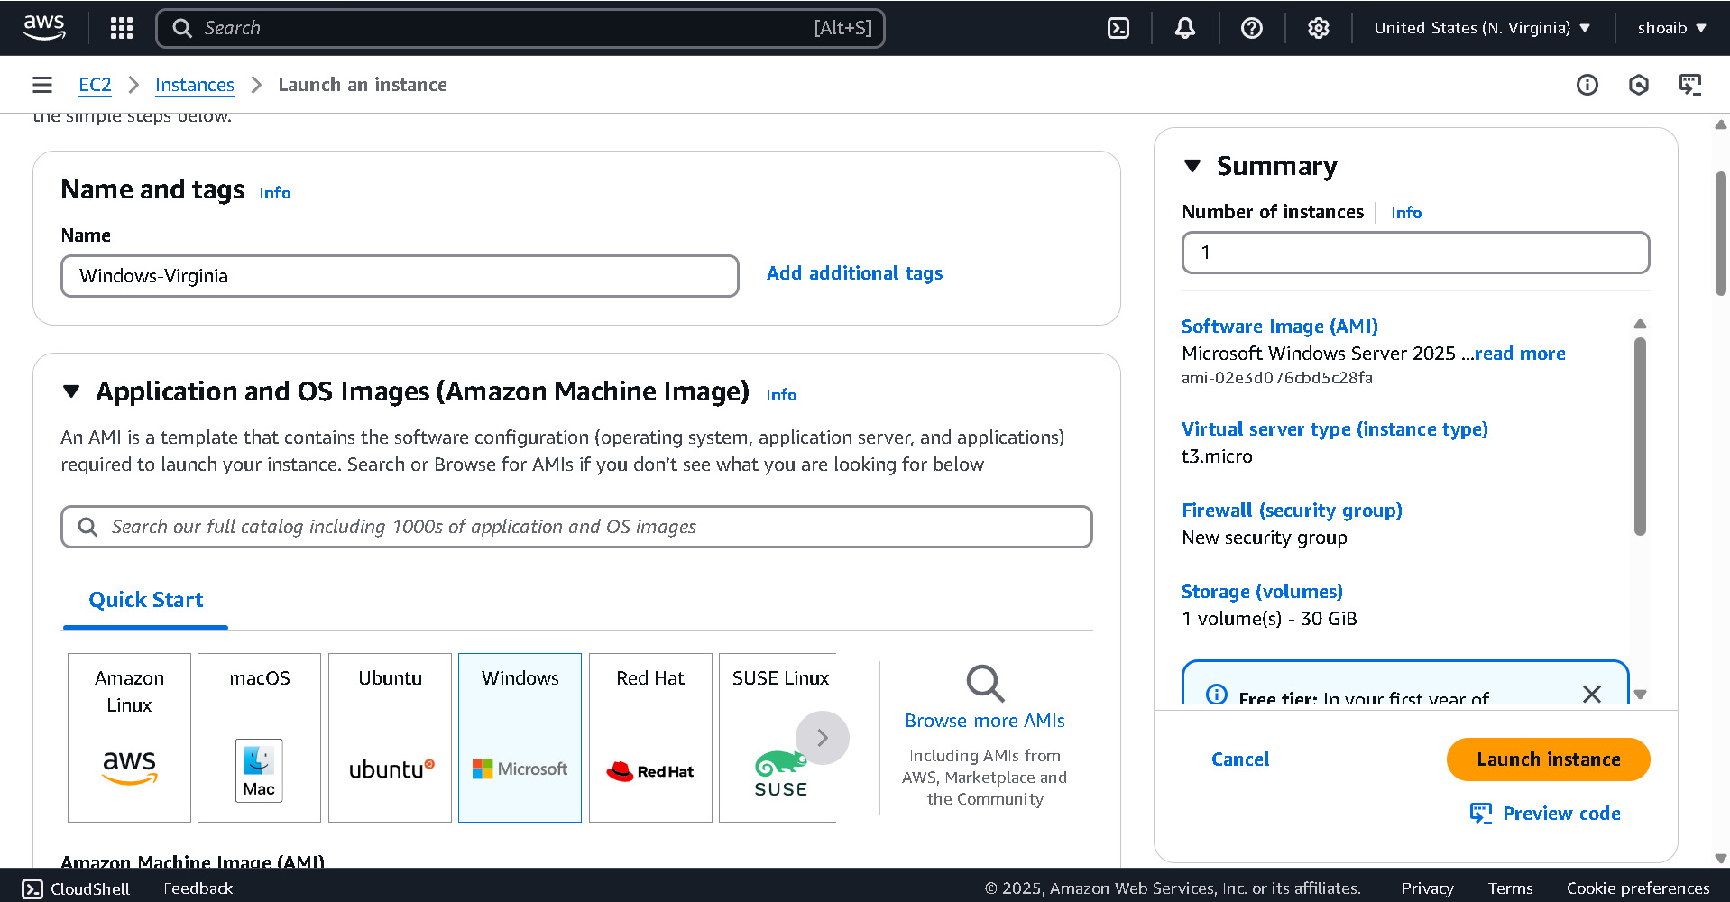

Add Instance in EC2 under Ohio Region

Add Security Rules

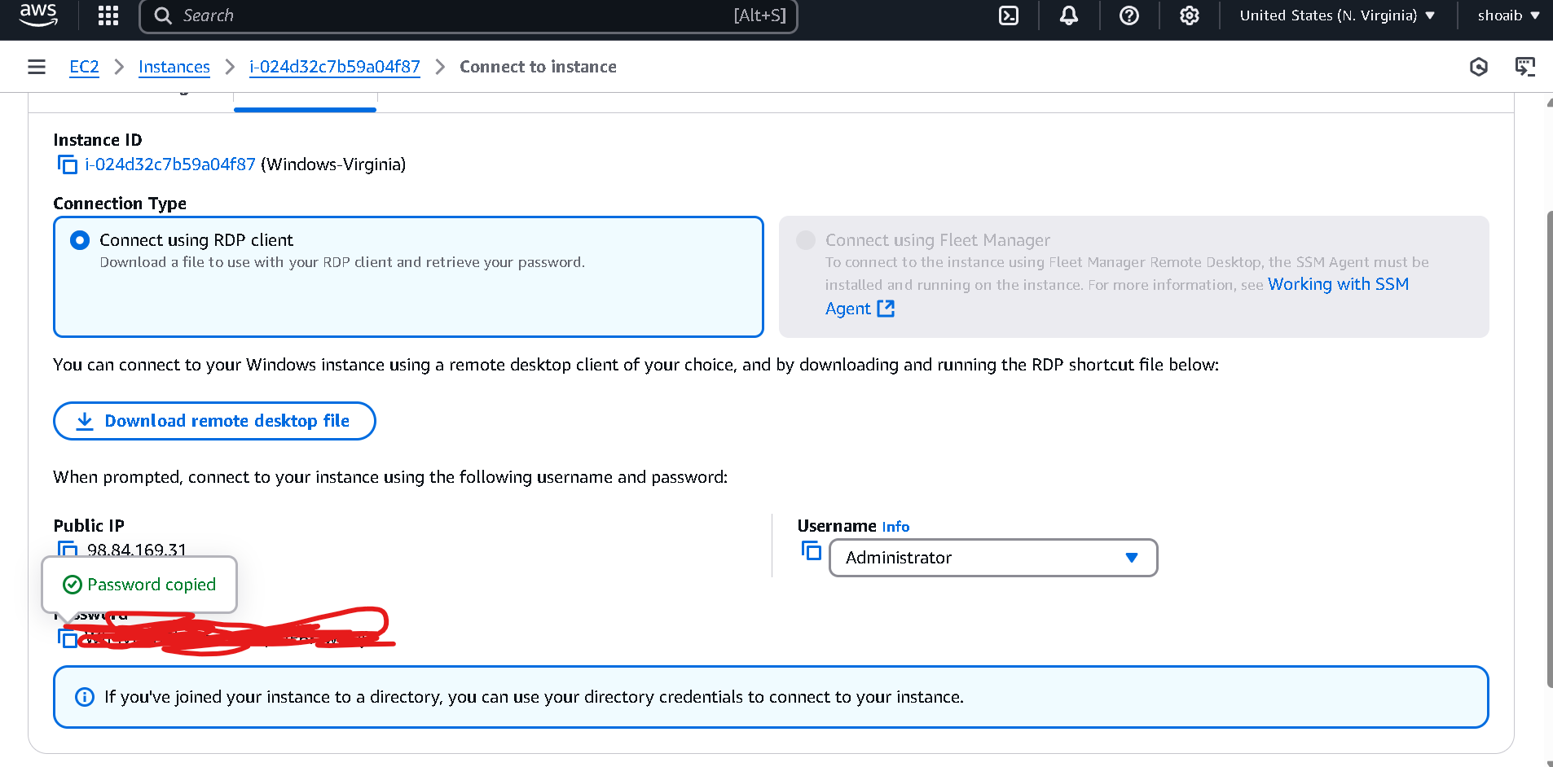

Now created AWS Screen

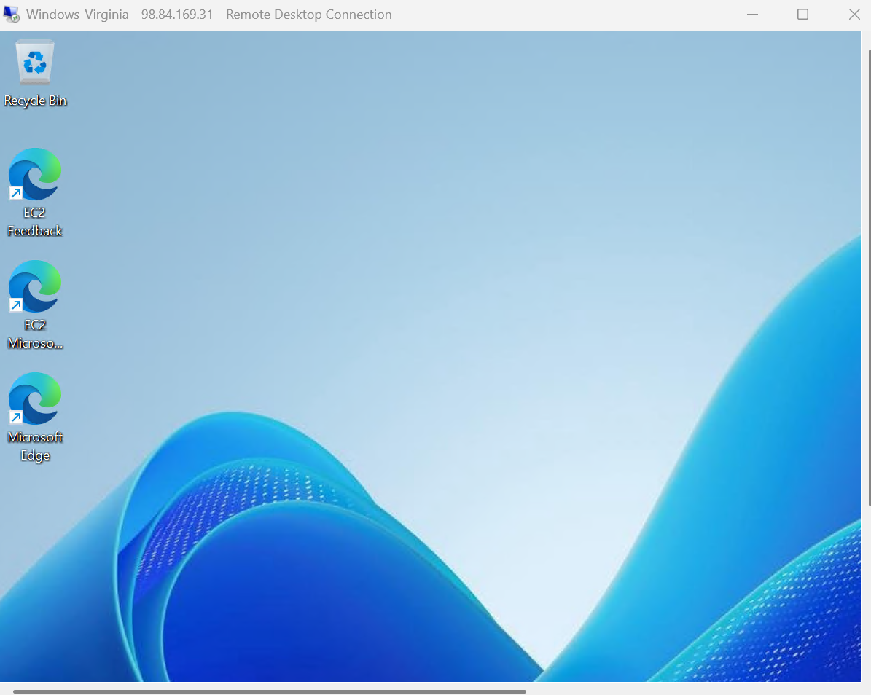

Download Putty Configuration



